**AUDIT 🡺 Issues found during testing & review**

Updating Code on SVN

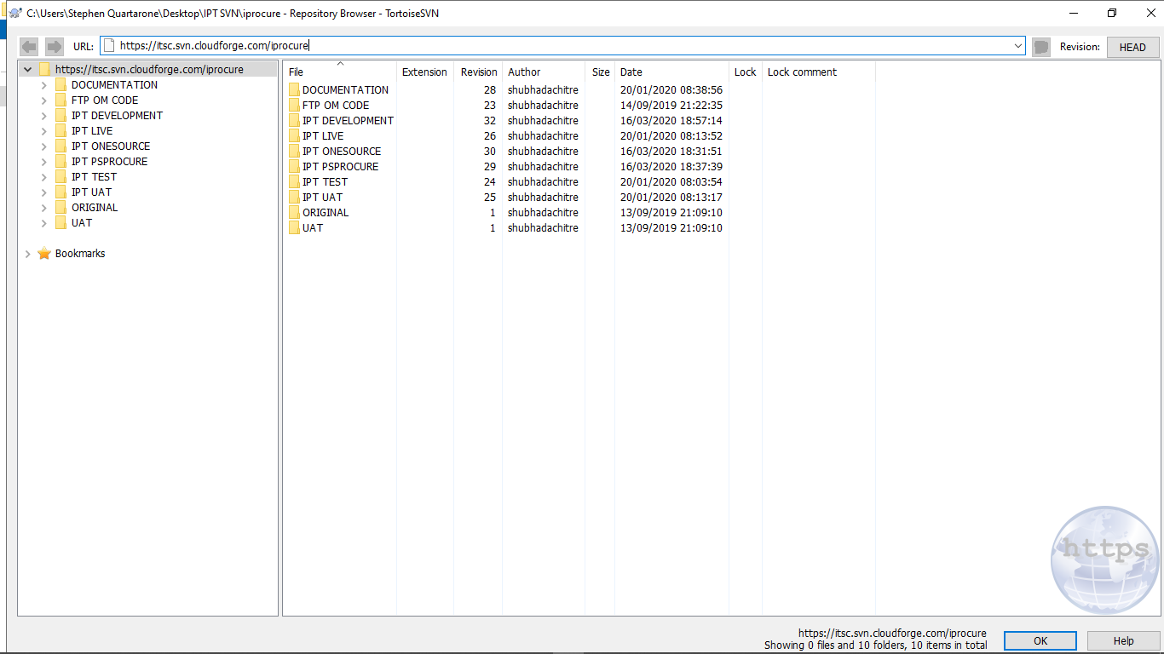

*Can you please confirm that all code & builds are now uploaded? Could you setup source code control so version control is taken care of automatically for this?*

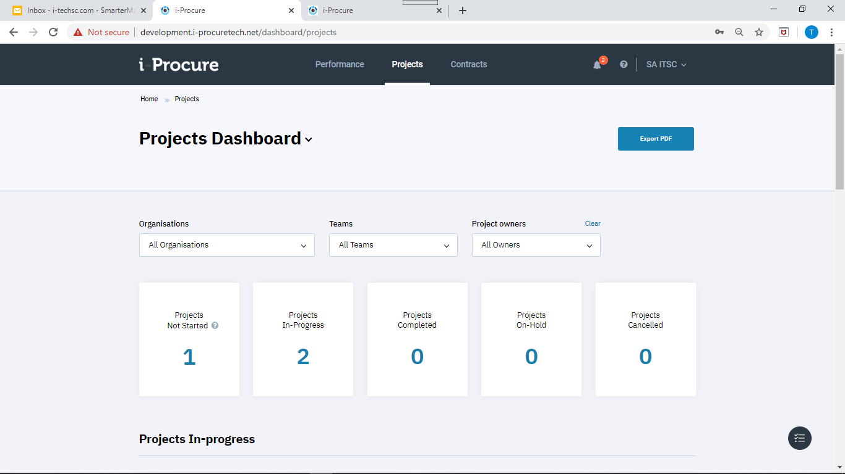

Logged in as TM, can see only 3 projects

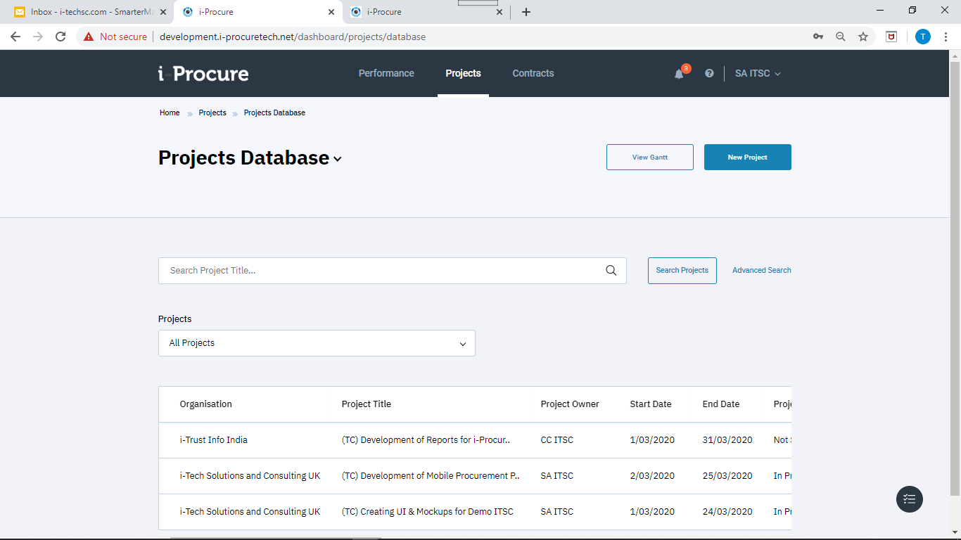

Projects Database also shows 3 projects

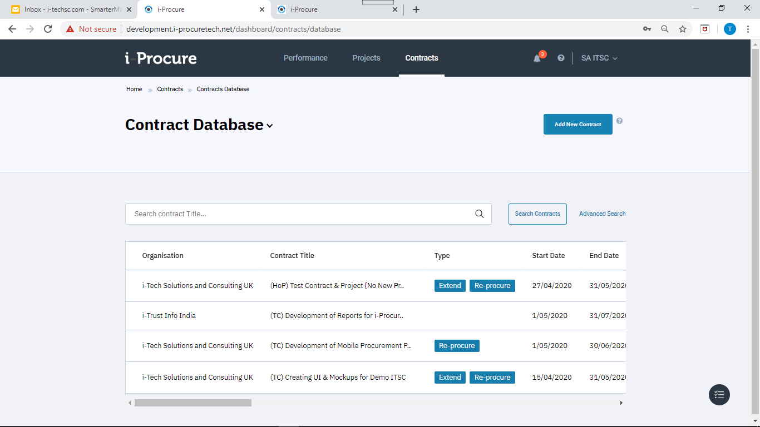

Did Advance Search in Contracts for Status = “In Project” and found 4 projects. Looks like Project created by HoP does not appear in the list. I remember this was fixed some time back when we found both Contracts & Projects created by HoP were not visible?

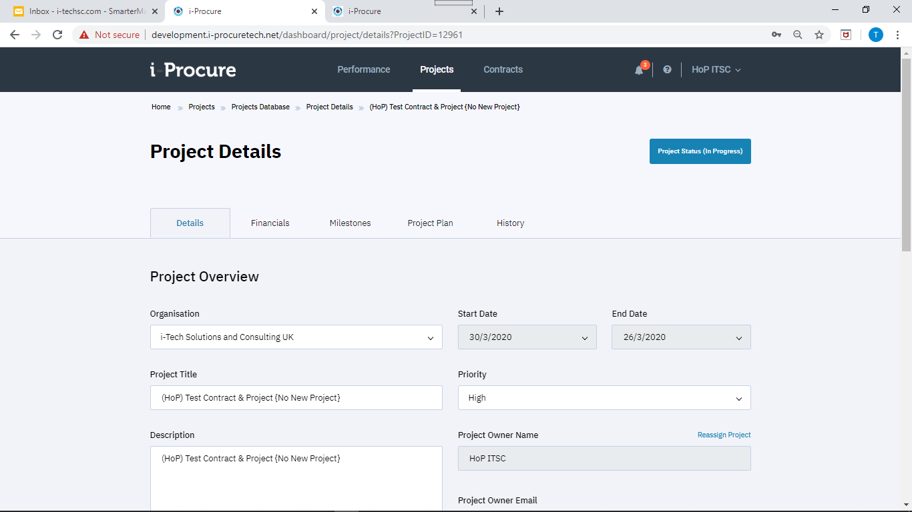

This is the project that is visible only to HoP 🡺 ProjectID=12961

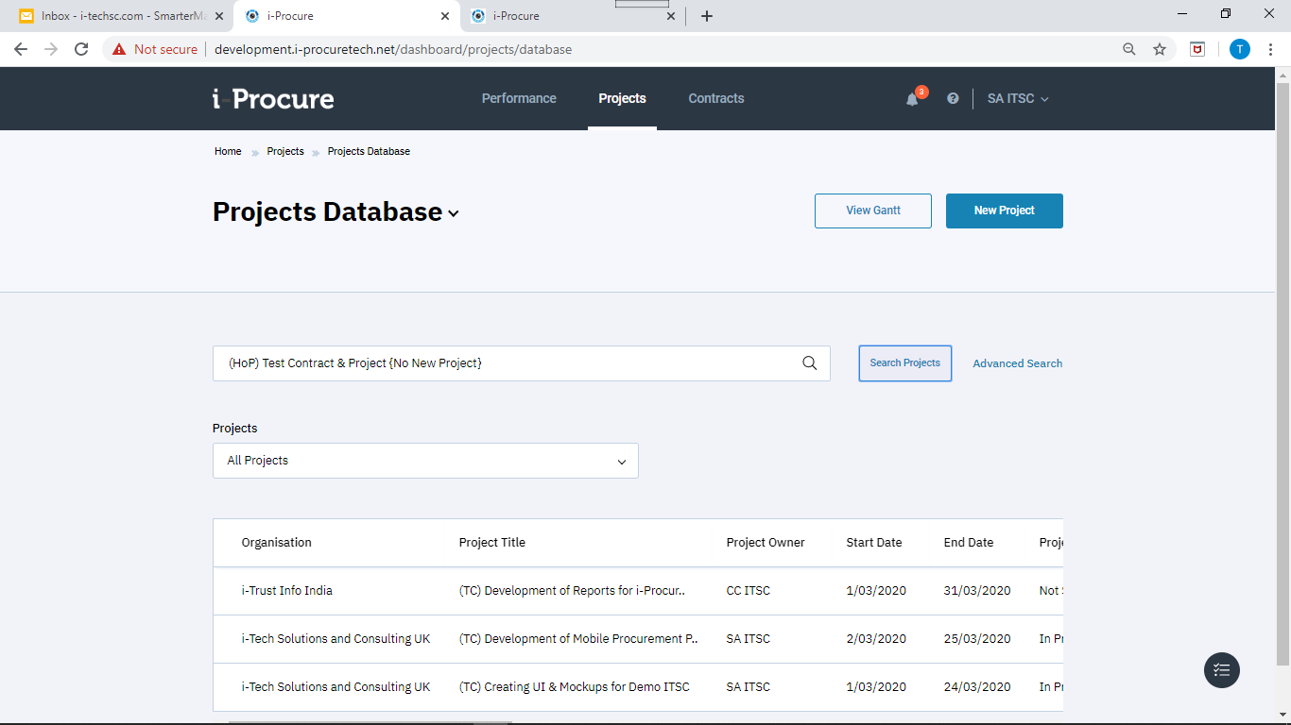

Tried searching the project with name (HoP) Test Contract & Project {No New Project} clicking search does nothing? Is this issue with special character & or { } ???

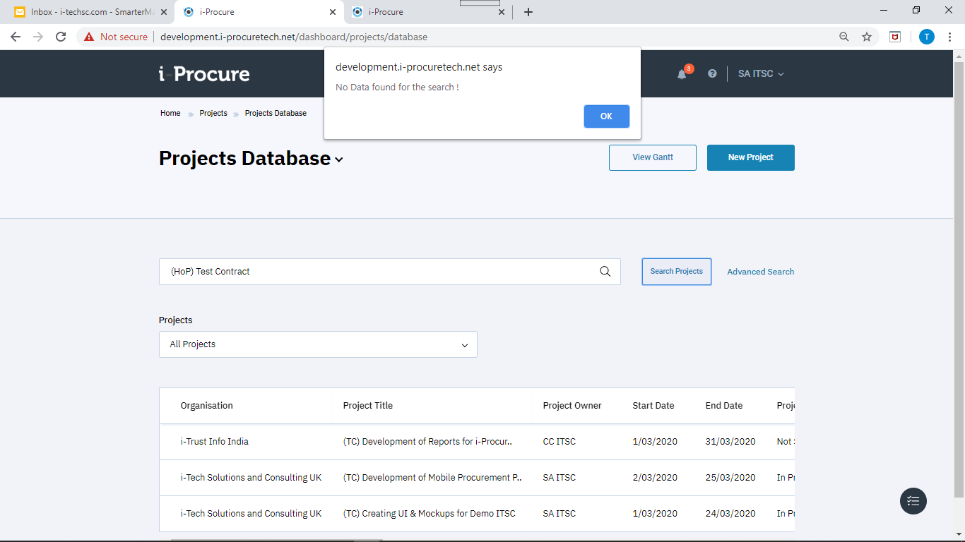

Yes definitely, see above. After removing & it worked! Can you please fix for both Contracts & Projects?

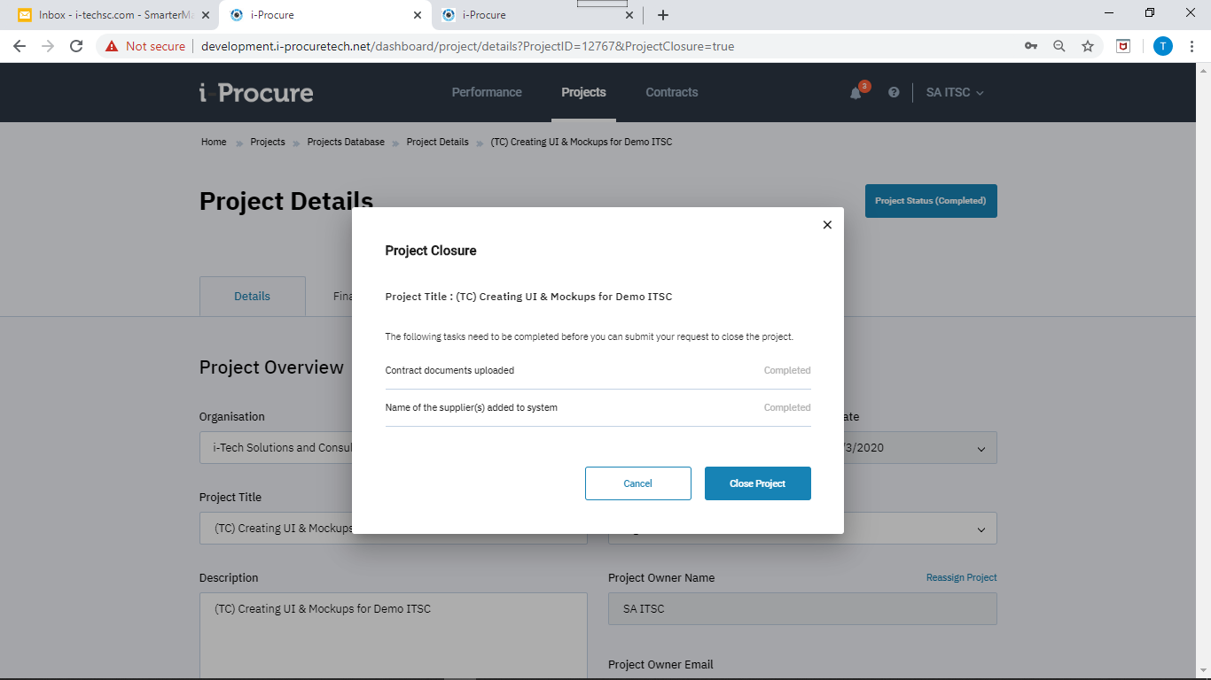

Logged in as TM and closed the project

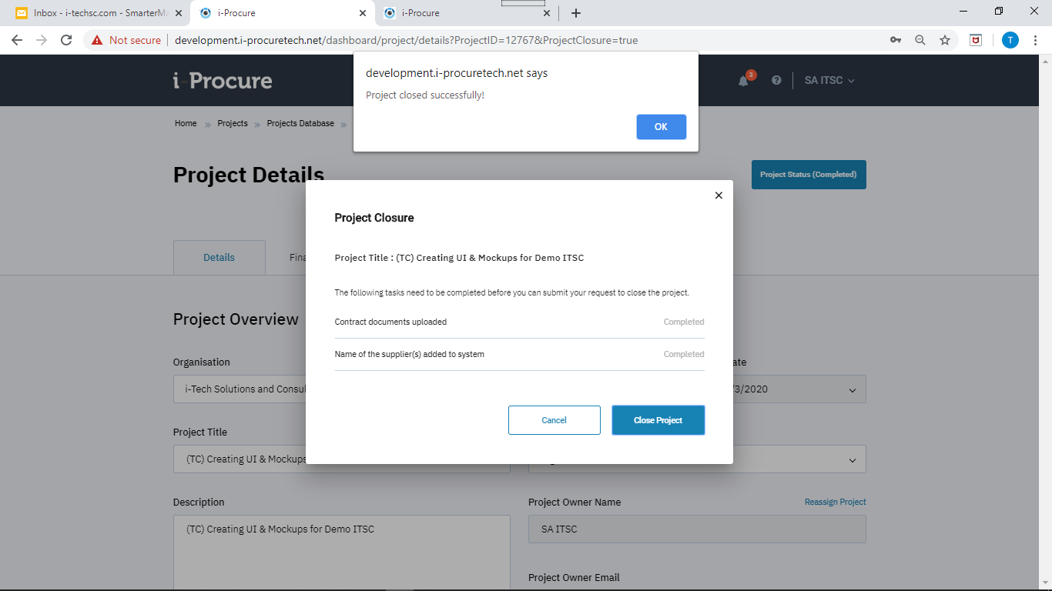

Closed successfully

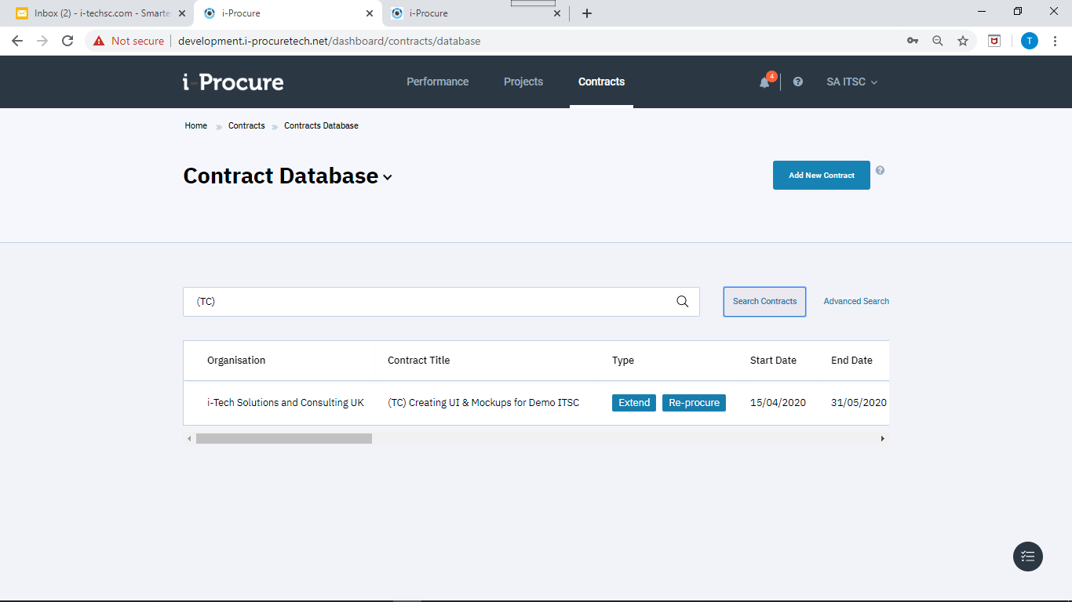

Contract has become “Live” so email should be sent to all informing a new contract is added?

Email is received for HoP and SA but not CC can you please check?

Notification in DOORBELL is received by SA but not by HoP or CC. *PLEASE FIX*

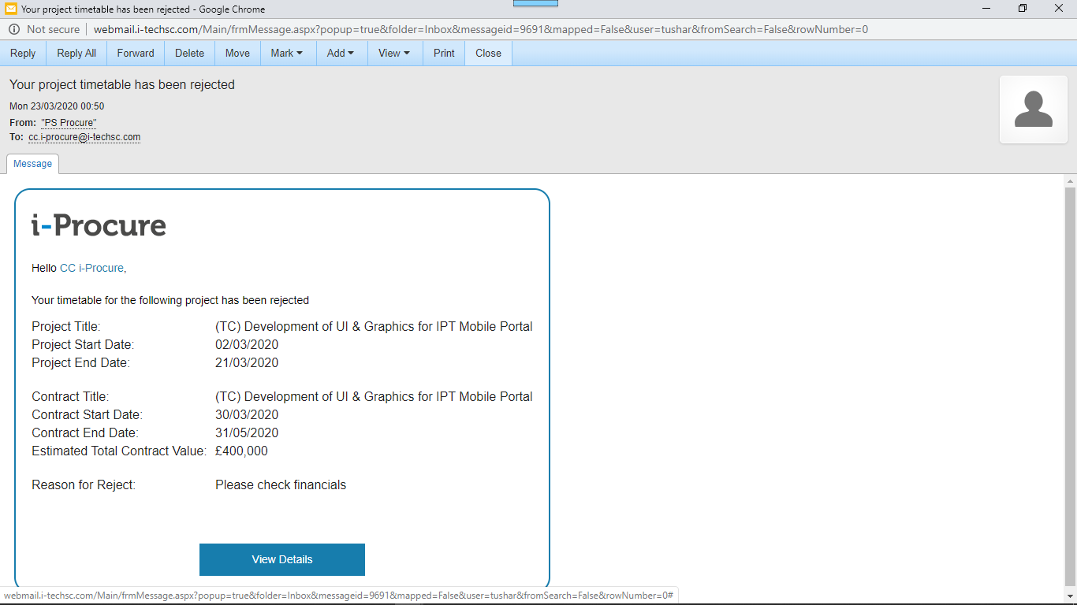

Email received but not the notification

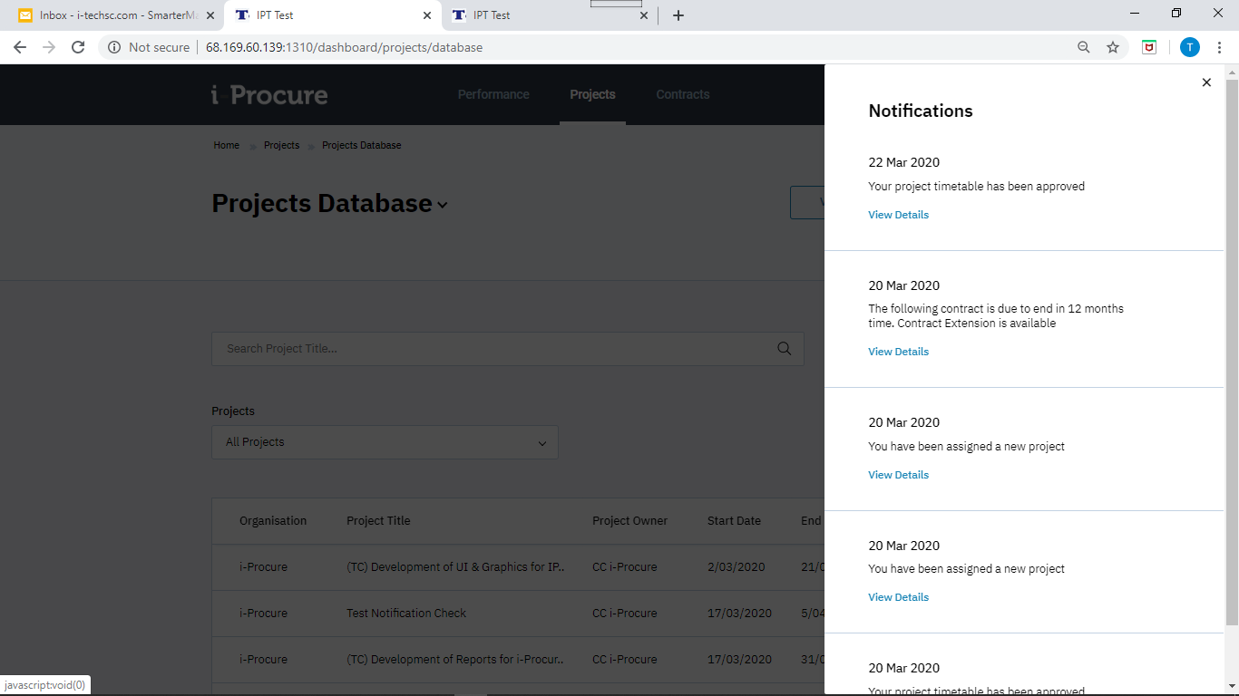

Accepted notification is received

*PLEASE CHECK ALL NOTIFICATIONS AGAIN? Is this checked?*

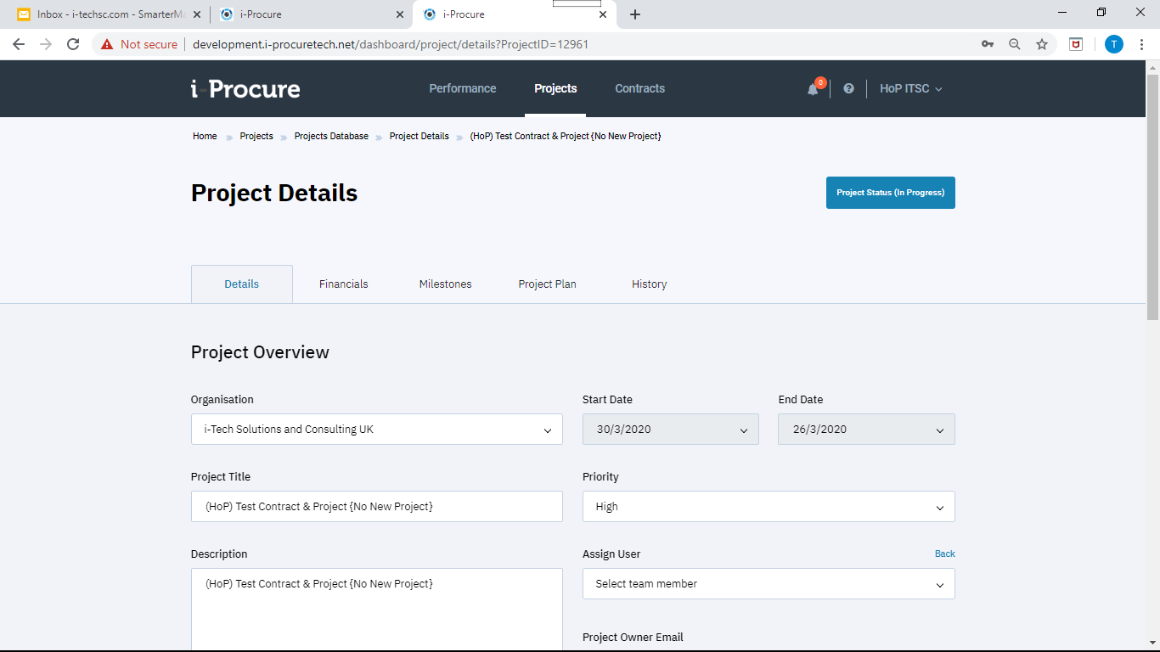

If I create Project / Contract as HoP no one can see this

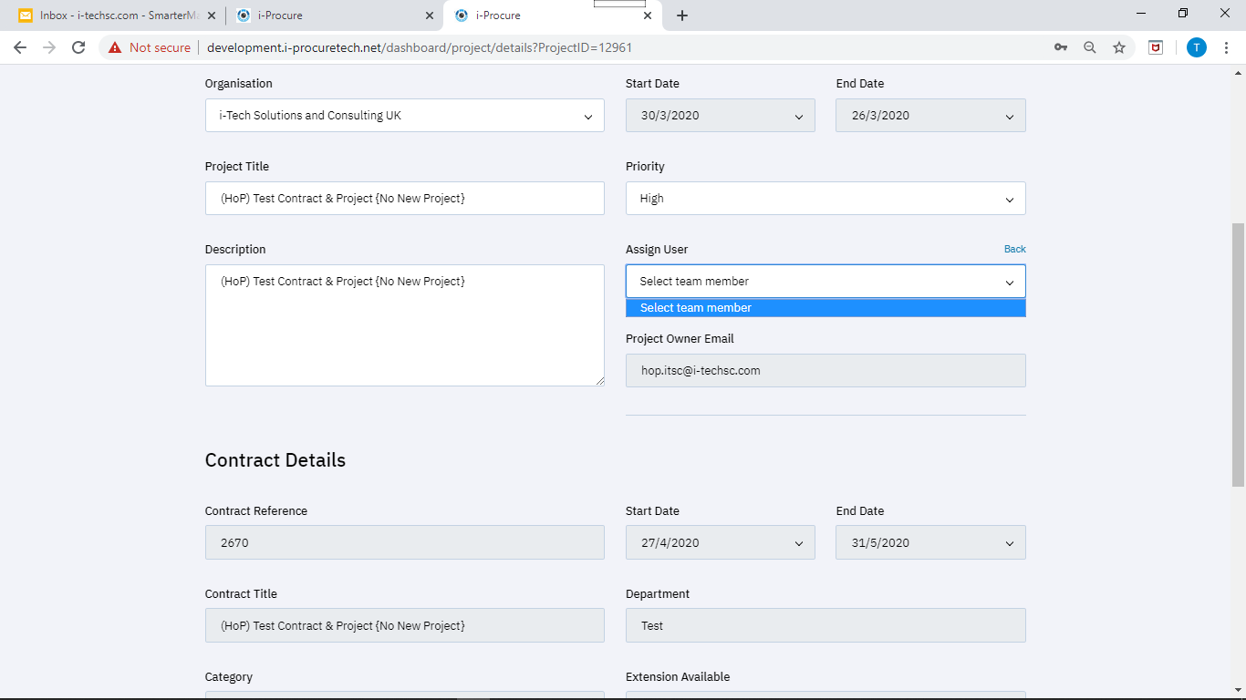

Reassign does not show any members

I think this was fixed but the bug reappears

<http://development.i-procuretech.net/dashboard/performance>

[hop.itsc@i-techsc.com](mailto:hop.itsc@i-techsc.com) / P@ssw0rd!

NOTIFICATIONS unhide

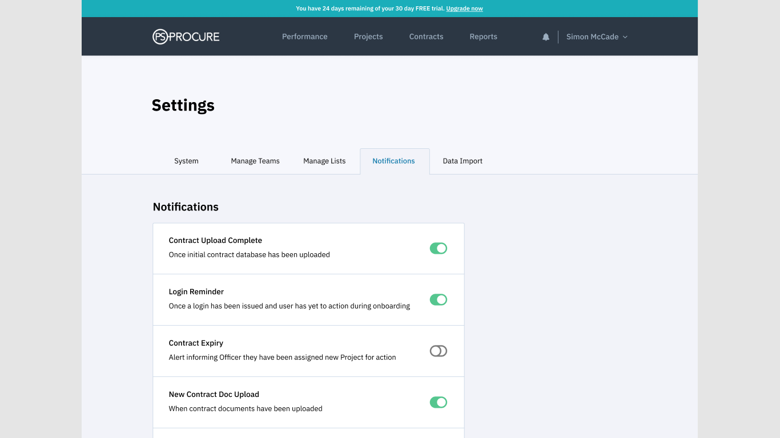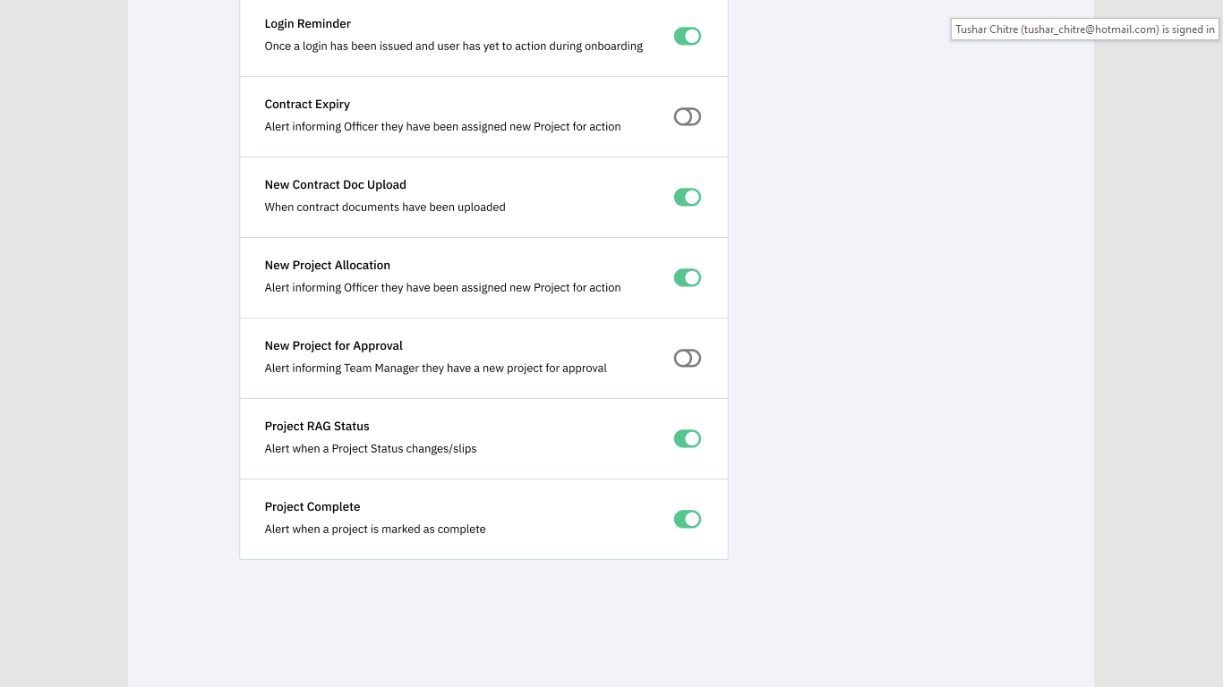

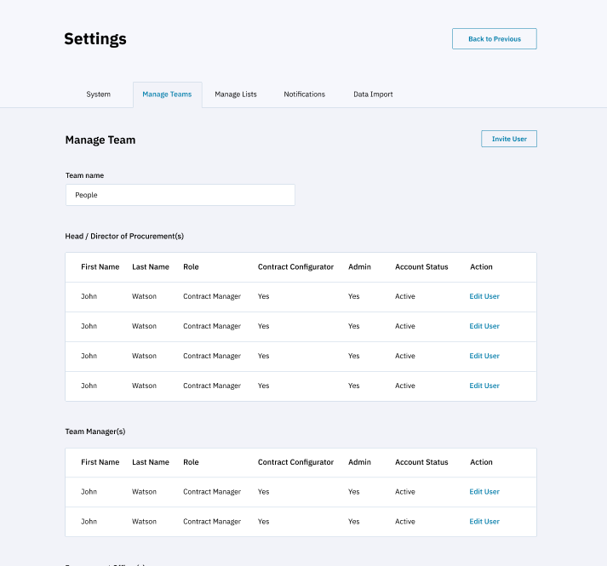

How do we create multiple HoPs? As shown in Figma? This is just a query no need to work anything.